**Our Philosophy**

Some agencies are brand centric. Some agencies are customer-centric. Channel 7 looks for what lies in between – The Relationship. Our relationship-centric approach solves the biggest paradox of our time. How can a brand be consistent – the hallmark of all successful brands – and also embrace change, perhaps the dominant characteristics of a world shaped by technology, globalization and convergence? Understanding relationships provides us with the solution. We believe that our struggle for creativity is never finished. We are constantly thinking about the brand. We always ask what can we do better. And always wonders what’s next. What’s the trend? What’s waiting to be noticed. We are constantly adopting and always moving forward. Always looking back. Always a work in progress.

**Our Tools**

At channel 7 we offer a board spectrum of advertising services ranging from in-depth research and analysis to strategy development which provides solid foundation for a great campaign.

* Customer insight
* Clients Insight
* Mapping

At channel 7 we offer a board spectrum of advertising services ranging from in-depth research and analysis to strategy development which provides solid foundation for a great campaign.

**Customer Insight**

By conducting the study where the customer is comfortable and amongst peers and friends and where the agency meets them face to face, without the distortion of one-way mirrors etc., ensures that real insights are gained.

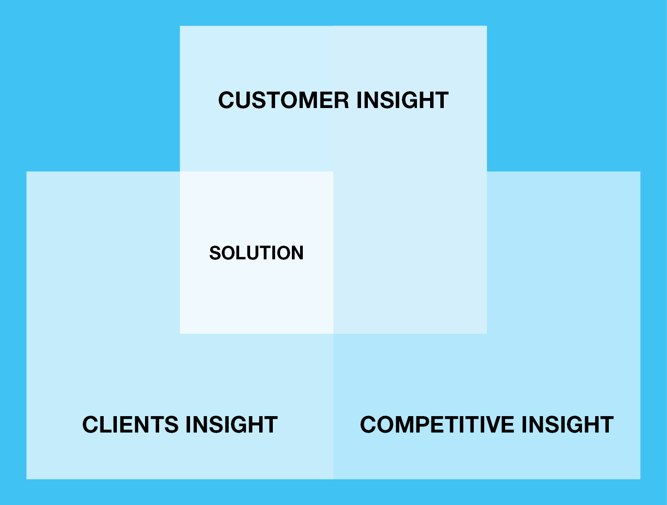

**Clients Insight**

Digs deep to extract the factors that differentiate each company and their brand. We feel there is no substitute for sitting down directly with clients to truly understand their perspective and to create shared ownership of new ideas.

**Mapping**

While many agencies are unbuilding their media departments, we believe that media must be fully integrated with in communications planning process. That’s why here at channel 7 we integrate the media and Clients service to help uncover those insights that brings us closer to both the brand and the customers.